CS 255 Business Requirements Document Template

System Components and Design

Purpose
What is the purpose of this project? Who is the client and what do they want their system to be able to do?
- The purpose of this project is to design and develop a web/mobile system for Driverpass. Mr. Liams vision is to make it where users can take online classes and practices tests and be able to provide customers with the option to be able to have on-the-road training. This is to help people be better prepared when going to the DMV when going for the driving test. The system should be able to have people make accounts, buy packages, take tests and classes, schedule appointments (call or do it online), track progress of. Depending on who is signed in by the company can access and do different things. Should have a tracker for modifications or adds of reservations also for the drivers and their vehicles for safety. The company should be able to remove and add packages they want in the future. Should get notifications from dmv to keep up to date with rules/ policies. The company should be able to update tests if need be. Progress of tests should be shown with driver notes.

System Background
What does DriverPass want the system to do? What is the problem they want to fix? What are the different components needed for this system?
- Driverpass company wants the system to help people be able to pass the DMV tests. Mr. Liam noticed that there were many people failing their driving tests at the DMV. So, he wants to be able to make better driver training. To do this he wants to have online tests and on the road driving lesson. The different components needed for the system are user accounts, schedule driving lessons, make appointments, cancel, and modify appointments, customer picks a package, track drivers and the car they will be in, driver notes, and DMV notifications for rule/policy updates. On the company side should be able to manage reservations, change passwords, modify packages, and keep user information safe.

Objectives and Goals
What should this system be able to do when it is completed? What measurable tasks need to be included in the system design to achieve this?
- When completed, users should be able to make accounts, buy the package they want, schedule their appointments, and get driver information. The system should track lessons, assign driver and car, driver notes, and test scores and progress. The company should be able to manage appointments, customer information, and reports. Notifications should go to the company to make sure tests and classes are up to date.

Requirements

Nonfunctional Requirements
In this section, you will detail the different nonfunctional requirements for the DriverPass system. You will need to think about the different things that the system needs to function properly.

Performance Requirements
What environments (web-based, application, etc.) does this system need to run in? How fast should the system run? How often should the system be updated?
- Ian stated that the “system needs to run off the web, preferably over the cloud.” So, this would mean we need the system to be web-based and cloud hosted, so DriverPass can focus more on the customers than the site itself. The system should run fast enough for multiple users performing operations simultaneously, such as taking practice tests, doing classes online, and scheduling appointments. The system should be updated whenever DMV rules or policies change, when packages need to be disabled or modified in anyway, when system updates are needed for maintenance such as security or system improvements in general.

Platform Constraints
What platforms (Windows, Unix, etc.) should the system run on? Does the back end require any tools, such as a database, to support this application?
- The system should run on windows, macOS, Linux/Unix, Android, and IOS. This is because the boss, Liam wants “to access data online from any computer or mobile device.”. Knowing that I would say the website should be able to work on a computer as well as a mobile device web browser. The back end does require a database, like mysql, to keep account information, reasons for cancellations, driver notes, reports, etc. An authentication service for users when logging in. The system will also require a web server to store, process, and deliver web content.

Accuracy and Precision
How will you distinguish between different users? Is the input case-sensitive? When should the system inform the admin of a problem?
- The different roles will have different levels of access Example:
  - Administrator
    - Reset passwords
    - Create accounts
    - Disable accounts
    - View all users
    - Manage permissions
    - View and download reports
  - Employee
    - View customer info
    - Schedule appointments
    - Update customer records
    - Create notes
    - Can reset customer passwords
    - Cannot create or delete employee accounts
  - Customer
    - View own account
    - Can reset own password by email
    - Schedule driving lessons
    - Take practice tests and classes
    - Cannot view other customers’ information
- The system will be able to know the difference between users by logging in. When logging in usernames will not be case sensitive but when inputting passwords those will be case sensitive. The system should inform the administrator of a problem when DMV rules need updates, when system updates are scheduled, and when employee accounts are locked out.

Adaptability
Can you make changes to the user (add/remove/modify) without changing code? How will the system adapt to platform updates? What type of access does the IT admin need?
- The admin will be able to add, remove, or modify the users. This will be done by having a user management tool that way code will not need to change. The admin will be able to create accounts, update user information, assign roles from the employees, and disable accounts when employees leave. The customer will be able create an account and be able to update own account information. The system is going to be web-based and cloud hosted. So, the updates, backups, or anything on the back end will not be handled by the DriverPass company. The IT admin will need full access to manage user accounts; adding, disabling, and resting passwords, assigning permissions, and monitoring account issues.

Security
What is required for the user to log in? How can you secure the connection or the data exchange between the client and the server? What should happen to the account if there is a “brute force” hacking attempt? What happens if the user forgets their password?
- For the user to log in they will need a username and case sensitive password. Also, will have a multi factor authentication will be for the phone text or email. They should have a three-limit attempt. To secure the connection between the client, DriverPass and the cloud based server they will encrypt data using HTTPS, use SSL Certificates to establish an authenticated and encrypted connection, will have firewalls to monitor traffic coming and going through the site, continually keep the software up to date, libraries and APIs, and backups for the site will also be done. If there is a brute force hacking attempt it will be locked and needs to be authenticated with an employee to be unlocked. If the user forgets their password should be able to press forgot password and be able to use their email to reset password.

Functional Requirements
Using the information from the scenario, think about the different functions the system needs to provide. Each of your bullets should start with “The system shall . . .” For example, one functional requirement might be, “The system shall validate user credentials when logging in.”
- The system shall validate user credentials when logging in
- The system shall allow customers to create accounts
- The system shall allow customers to reset passwords
- The system shall provide online class and practice tests
- The system shall track user information and driver information
- The system shall allow users to schedule appointments
- The system shall assign instructors/drivers in the general area
- The system shall securely store customer information
- The system shall collect test information whether done or in progress or what is next
- The system shall allow users to purchase packages
- The system shall allow data reports to be downloaded for offline viewing
- The system shall have a way for customers to contact DriverPass
- The system shall allow administrators to manage user permissions

User Interface
What are the needs of the interface? Who are the different users for this interface? What will each user need to be able to do through the interface? How will the user interact with the interface (mobile, browser, etc.)?
- The needs of the interface are it should have a log in/ create account, should have a customer test information area (shows the status of the tests and grades), driver notes(having times and comments left), an account information page(users can update account information), package page showing all the different options the user can purchase, and a contact page(this will be DriverPass info locations, phone numbers, hours open).
- The different users are the administrators, the employees, and the customers. So, with each user their interface will look a bit different. Through the interface the administrators will need to be able to manage all accounts, view and download reports, update packages, update contact information. The employees should be able to manage customer accounts and schedule appointments. The customers should be able to create/ log in to own account, take tests and classes, schedule own appointments, and view drivers notes.
- The user will be able to interact with the interface through the web browser using a computer or mobile device. In the interview Liam states he wants to “access the data from any computer or mobile device.”

Assumptions
What things were not specifically addressed in your design above? What assumptions are you making in your design about the users or the technology they have?
- The things not addressed in my design above are what payments we will take(visa, discover, etc.), should we have a mobile app, will the website still function properly on the phone browser, what browser we are tailoring for, and what cloud provider will be partnering with. The assumption I am making about the design is that any user will be able to pick it up and know how to navigate the website, the user will have either a computer or phone, and that the system will run smoothly with the cloud provider.

Limitations
Any system you build will naturally have limitations. What limitations do you see in your system design? What limitations do you have as far as resources, time, budget, or technology?
- The limitations that I see are whether the users must have access to a phone or computer to be able to access DriverPass. Another limitation would be if the user lost or does not have internet access, whether there is an outage phone or modem offline. They wouldn’t be able to access their tests or classes during that time. Another limitation is that DriverPass will be a web-based system not a mobile app, this in turn may be less convenient. The limitations for us when making this program are time and technology constraints. This is because we are going to be working on this in a time limit of about 4 months. We will be debugging as we go but some bugs may not be discovered until later testing. This is because we first need to design what needs to be done and start coding around March 12 if DriverPass agrees on what we have planned by then. Technology is a limitation just because we won’t be making an app during this time just the browser.

Gantt Chart
Please include a screenshot of the GANTT chart that you created with Lucidchart. Be sure to check that it meets the plan described by the characters in the interview.

DriverPass: Schedule Plan: Lucidspark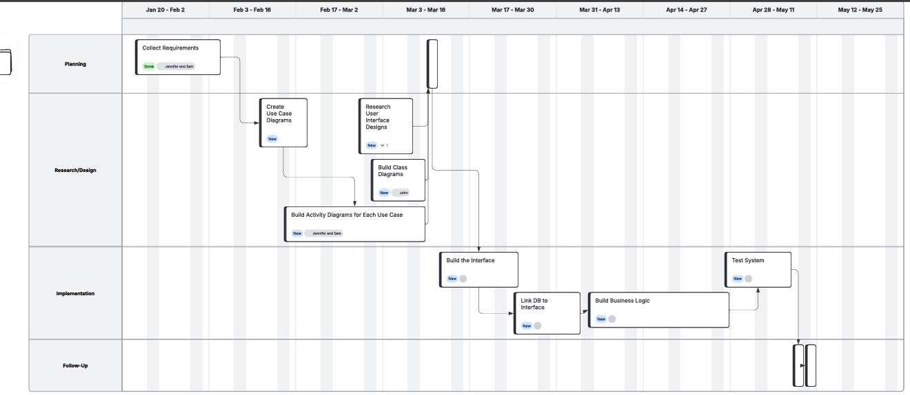
Chart Notes: Planning: Small square is Get Customer Approval Follow-Up: Small Squares in follow up are deliver system and sign off meeting

